Lab #13:

Task #1:

#include<iostream>

using namespace std;

bool palindrome(int num);

int main()

{

int n;

cout << "Enter the Number "; /\*Taking input for Palindrome Number \*/

cin >> n;

bool temp;

temp = palindrome(n);

if (temp == 1) /\*Making conditions for that number \*/

{

cout << "The Number is Paindrome " << endl;

}

else if (temp == 0)/\*False condition\*/

{

cout << "The Number is not palindrome " << endl;

}

system("pause");

return 0;

}

bool palindrome(int num) /\*Functions \*/

{

int digit= 0;

int temp1 = num;

while (num>0) /\*These are conditions for that Number \*/

{

digit = digit \* 10 + num % 10; /\*Remove the first and last Number \*/

num = num / 10;

}

if (temp1 == digit)/\* Final condition\*/

return true;

return false;

system("pause");

}

Output:

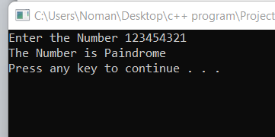

Task #2:

#include<iostream>

using namespace std;

int Num(int N) /\*Making function of name Num\*/

{

int nthterm;

nthterm = (N\*((N / 2) + ((N % 2) \* 2) + N)); /\*This is the Formula for Number \*/

return nthterm;

}

int main()

{

int n;

cout << "Enter the Number : "; /\*Taking Input\*/

cin >> n;

cout << endl;

cout << Num(n); /\*Calling the function\*/

system("pause");

return 0;

}

Output:

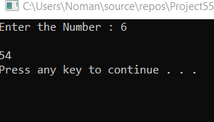

Task #3:

#include<iostream>

using namespace std;

int fac(int n)

{

int factorial=1;

if (n < 0) /\*Making conditions for Negative Number \*/

{

cout << "Error! Negative Number does not exsist ";

}

else

{

for (int i = 1; i <= n; i++)

{

factorial \*= i; /\*This is Logic for factorial of a Number \*/

}

}

return factorial;

}

int main()

{

int num;

cout << "enter the Number :"; /\*Taking input\*/

cin >> num;

cout << "The factorial a number is : " << fac(num);/\* calling the function\*/

cout << endl;

system("pause");

return 0;

}

Output:

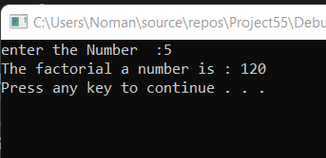

Task #5:

#include<iostream>

using namespace std;

void swap(int&a, int& b)

{

int temp;/\* taking some varaibles \*/

temp = a;/\*swapping variables\*/

a = b;

b = temp;

system("pause");

}

int main()

{

int a, b;

cout << "Before swapping : " << endl;

cout << "Enter the value of a "; /\*Taking input\*/

cin >> a;

cout << "Enter the value of b ";

cin >> b;

cout << "After swapping " << endl;

cout << b<<" ," << a; /\*Displaying the Numbers \*/

system("pause");

}

Output:

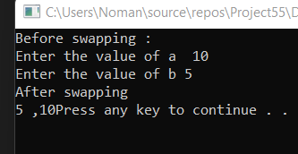

Task #6:

#include<iostream>

#include<iomanip>

#include<time.h>

using namespace std;

int main()

{

cout << "I have a number between 1 and 1000" << endl;

cout << "Can you guess my Number ?" << endl;

cout << "Please type your first Guess " << endl;

int count = 0;

srand(time(0)); /\*Here the system will guess any Number\*/

int x = rand() % 1000;

int y;

cout << "Enter the number to be guessed :"; /\*Here we are taking input \*/

cin >> y;

cout << endl;

while (y != x) /\*it will search guessing number if the entered number will not equal to number then loop will true otherwise loop will terminate \*/

{

if (y > x)

{

cout << "Too High" << endl;

}

else

{

cout << "Too Low " << endl;

}

cout << "Would you like to play again,So Enter any number :";

cin >> y;

count++;

}

cout << "The Number of Turns : " << count << endl;

system("pause");

return 0;

}

Output:

